**Lab02**



**Spring 2025**

Submitted by: **Mohsin Sajjad**

Registration No: **22pwsce2149**

Class Section: **A**

“On my honor, as student of University of Engineering and Technology, I have neither given nor received unauthorized assistance on this academic work.”



Student Signature: ______________

Submitted to:

**Engr. Faheem Jan**

Month Day, Year (16 02, 2025)

Department of Computer Systems Engineering

University of Engineering and Technology, Peshawar

# LAB No 2

**Objectives:**

This lab will enable students to:

* + Learn top down and bottom up design methodologies
  + Data flow level modeling

**TASK 1:**

**4 bit Ripple Carry Adder**

**Block Diagram:**

Following is the block diagram of a 4 bit Ripple Carry Adder.

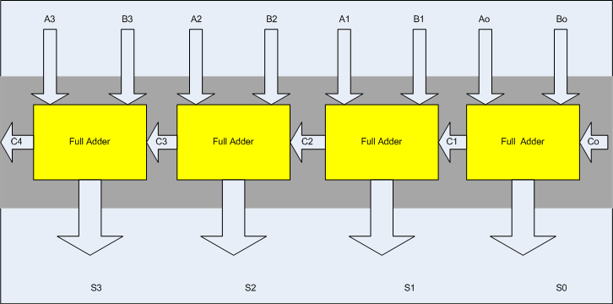

**Steps for task 1a:**

The following steps should be performed while designing a 4 bit RCA adder

**ModelSim:**

1. First implement a Full adder using data gate level modeling.
2. Simulate the Full adder with a test bench.
3. Instantiate the Full adder four times and connect the circuit as shown.
4. Now again write a test bench and simulate the 4 bit RCA.

**CODE:**module Sum(S,A,B);

input A,B;

output S;

xor x(S,A,B);

endmodule

module Carry(C,A,B);

input A,B;

output C;

and a(C,A,B);

endmodule

module HA(S,C,A,B);

input A,B;

output S,C;

Sum s1(S,A,B);

Carry c1(C,A,B);

endmodule

module FA(S,C,A,B,Cin);

input A,B,Cin;

output S,C;

wire S1,C1,C2;

HA h1(S1,C1,A,B);

HA h2(S,C2,Cin,S1);

or o(C,C1,C2);

endmodule

module RCA(S,Cout,A,B,Cin);

input [3:0] A,B;

input Cin;

output [3:0] S;

output Cout;

wire [2:0] C;

FA f1(S[0],C[0],A[0],B[0],Cin);

FA f2(S[1],C[1],A[1],B[1],C[0]); // Unique instance name

FA f3(S[2],C[2],A[2],B[2],C[1]); // Unique instance name

FA f4(S[3],Cout,A[3],B[3],C[2]); // Unique instance name

endmodule

module RCA_tb();

reg [3:0] A,B;

reg Cin;

wire [3:0] S;

wire Cout;

RCA rr(S,Cout,A,B,Cin);

initial begin

A = 4'b0000; B = 4'b0001; Cin = 1'b0;

#20;

A = 4'b0101; B = 4'b0011; Cin = 1'b0;

end

initial

$monitor("A=%b B=%b Sum=%b Cout=%b", A, B, S, Cout);

endmodule

**OUTPUT:**

**Truth Table:**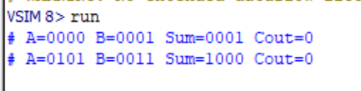

**Wave output:**

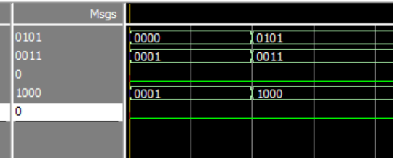

**Task 1b:**

Design the 4 bit full adder using data flow level modeling.

**CODE:**

module HA(S, C, A, B);

input A, B;

output S, C;

assign S = A ^ B;

assign C = A & B;

endmodule

module FA(S, C, A, B, Cin);

input A, B, Cin;

output S, C;

assign S = A ^ B ^ Cin;

assign C = (A & B) | (B & Cin) | (A & Cin);

endmodule

module RCA2(S, Cout, A, B, Cin);

input [3:0] A, B;

input Cin;

output [3:0] S;

output Cout;

wire [2:0] C; // Internal carry wires

// Ripple Carry Adder using Dataflow

FA fa0(S[0], C[0], A[0], B[0], Cin);

FA fa1(S[1], C[1], A[1], B[1], C[0]);

FA fa2(S[2], C[2], A[2], B[2], C[1]);

FA fa3(S[3], Cout, A[3], B[3], C[2]);

endmodule

module RCA_tb2();

reg [3:0] A, B;

reg Cin;

wire [3:0] S;

wire Cout;

RCA rr(S, Cout, A, B, Cin);

initial begin

A = 4'b0000; B = 4'b0001; Cin = 1'b0;

#20;

A = 4'b0101; B = 4'b0011; Cin = 1'b0;

end

initial

$monitor("A=%b B=%b Sum=%b Cout=%b", A, B, S, Cout);

endmodule

**Output:  
Truth Table:**

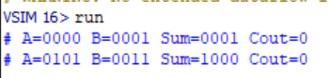

**Wave output:**

